Mechanical Overview

Year: 2023 Semester: Spring Team: 8 Project: Engineer’s Chess

Creation Date: 2/6/2023 Last Modified: September 19, 2021

Author: Andrew Helton Email: helton4@purdue.edu

Assignment Evaluation:

| **Item** | **Score (0-5)** | **Weight** | **Points** | **Notes** |
| --- | --- | --- | --- | --- |
| **Assignment-Specific Items** | | | | |
| **Commercial Packaging Analysis 1** |  | x2 |  |  |
| **Commercial Packaging Analysis 2** |  | x2 |  |  |
| **CAD Model Illustrations** |  | x4 |  |  |
| **Project Packaging Specifications** |  | x2 |  |  |
| **PCB Footprint Layout** |  | x2 |  |  |
| **Writing-Specific Items** | | | | |
| **Spelling and Grammar** |  | x2 |  |  |
| **Formatting and Citations** |  | x1 |  |  |
| **Figures and Graphs** |  | x2 |  |  |
| **Technical Writing Style** |  | x3 |  |  |
| **Total Score** |  | | |  |

5: Excellent 4: Good 3: Acceptable 2: Poor 1: Very Poor 0: Not attempted

Comments:

*Comments from the grader will be inserted here.*

1. Commercial Product Packaging

The two products that were analyzed for similarities to our project were “Square Off’s Grand Kingdom Set”[1] and “Top 1 Chess’s Electronic Chess Set”[2].

* 1. Product #1

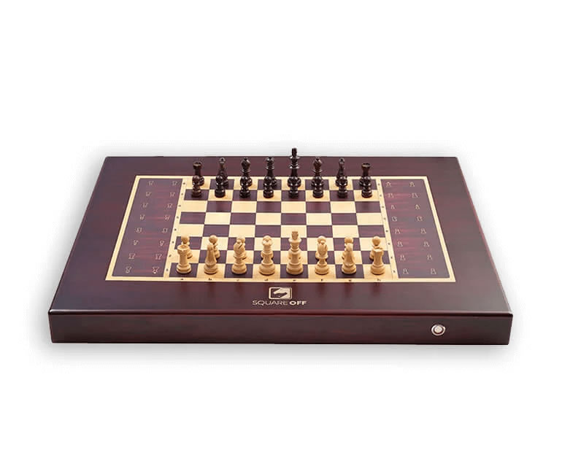

Figure 1: Packaging of Product #1

The design of the “Grand Kingdom Set” is made to appear very well made as it is constructed from polished wood of multiple color variations. To use the device a user must have a smartphone with bluetooth with the correct application installed on their device. It also has a monotone speaker for audio output. If playing with another human that is not present or against an A.I., the opponents' pieces move on their own.

With the all wood design, this chess board is made to look like other wooden chess boards, while maintaining its added features. While wood is not the most inexpensive material to use, the purpose of this product is not to be sold en masse, but rather to be purchased only by chess aficionados. Thus using a costly material, that looks good on display, makes the product look less like a gimmick and more like any other chess board.

For our team’s device, we plan to also use wood for the main packaging material. Our interface, however, will not require the use of a smartphone. Instead, our product will have multiple input buttons to control the interfaces. Our product also differs as our game will be displayed using a LED matrix to display the game, rather than the traditional physical pieces elements.

* 1. Product #2

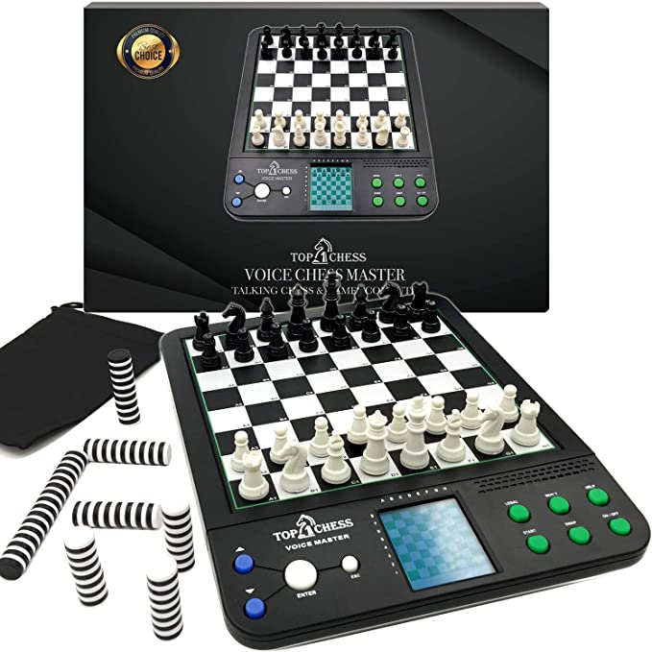

Figure 2: Packaging of Product #2

The “Electronic Chess Set” made by Top Chess, features a plastic case with a physical plastic chess board. The front of the package also had ten buttons for user interfacing and a LCD screen displaying the game. There is also a speaker above the six green buttons on the right so that the audio from the game can be heard.

Unlike the last product, this design uses primarily plastic for its exterior packaging, buttons, and chess pieces. This allows for more unique design shapes than wood would, as it is more flexible and easier to mold to make non-linear edges. The plastic also makes the design light weight and easy to handle. The placement of the main interfaces all being on one side is a major downside. When playing with two players, only one will have easy access to the buttons that help navigate the chess game.

In our design implementation, we specifically wanted to have two user interfaces, one on each side of the chess board, so that both players will have easy access to the controls allowing them to operate the game. This differs significantly from Product 2 which only has one set of controls. While that is easier to design electronically, it makes using the chessboard a difficulty with two players, which is something our team considered when we designed our interfaces.

2.0 Project Packaging Description

Our chessboard will be contained in a wooden box that we construct. As seen in Appendix 1, the base of the box will be 292 x 292 mm. The diagonal pieces that the interfaces will be attached to will be 192 x 39 mm. The upper piece that the LEB matrix will sit in will be 292 x 242 mm, with a square hole of 192 x 199 mm cut out of the center. The two side pieces will be trapezoidal, with a base of 292, a height of 60 mm, and edges of length 39 mm. The holes for the LCD displays will be 80 x 24 mm. Once the pieces are cut, we will stain them with wood stainer to get a better color. To keep the wood together we plan on using wood glue along the edges of all the connecting pieces.

3.0 Sources Cited

[1] “Square Off Grand Kingdom set: The Royalty Chess Set,” *Square Off*. [Online]. Available: https://squareoffnow.com/product/gks?gclid=CjwKCAiA85efBhBbEiwAD7oLQP-TB8YX3mmifL2efr0YdZlAiBG-i8j3VMSjttPVMyO0ZdbDJmVmcBoCZzQQAvD_BwE. [Accessed: 10-Feb-2023].

[2] “www.amazon.com,” *Top 1 Chess Electronic Chess Set*. [Online]. Available: https://www.amazon.com/Top-Classical-Computer-Teaching-Strategy/dp/B07RZ5TQF2. [Accessed: 10-Feb-2023].

Appendix 1: CAD Model Illustrations

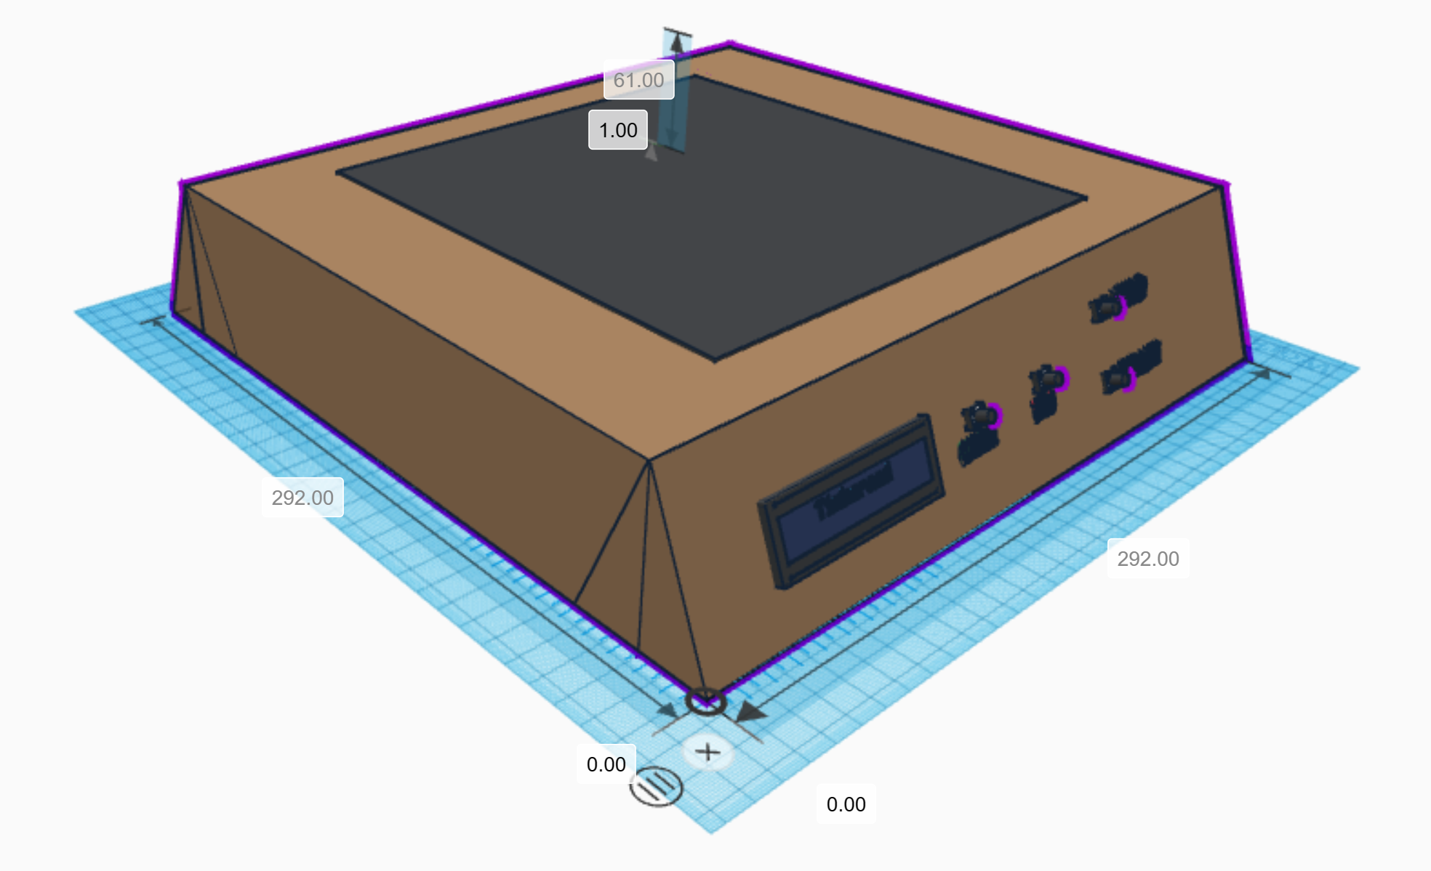

Figure 3: Angled view of the chessboard (units in mm)

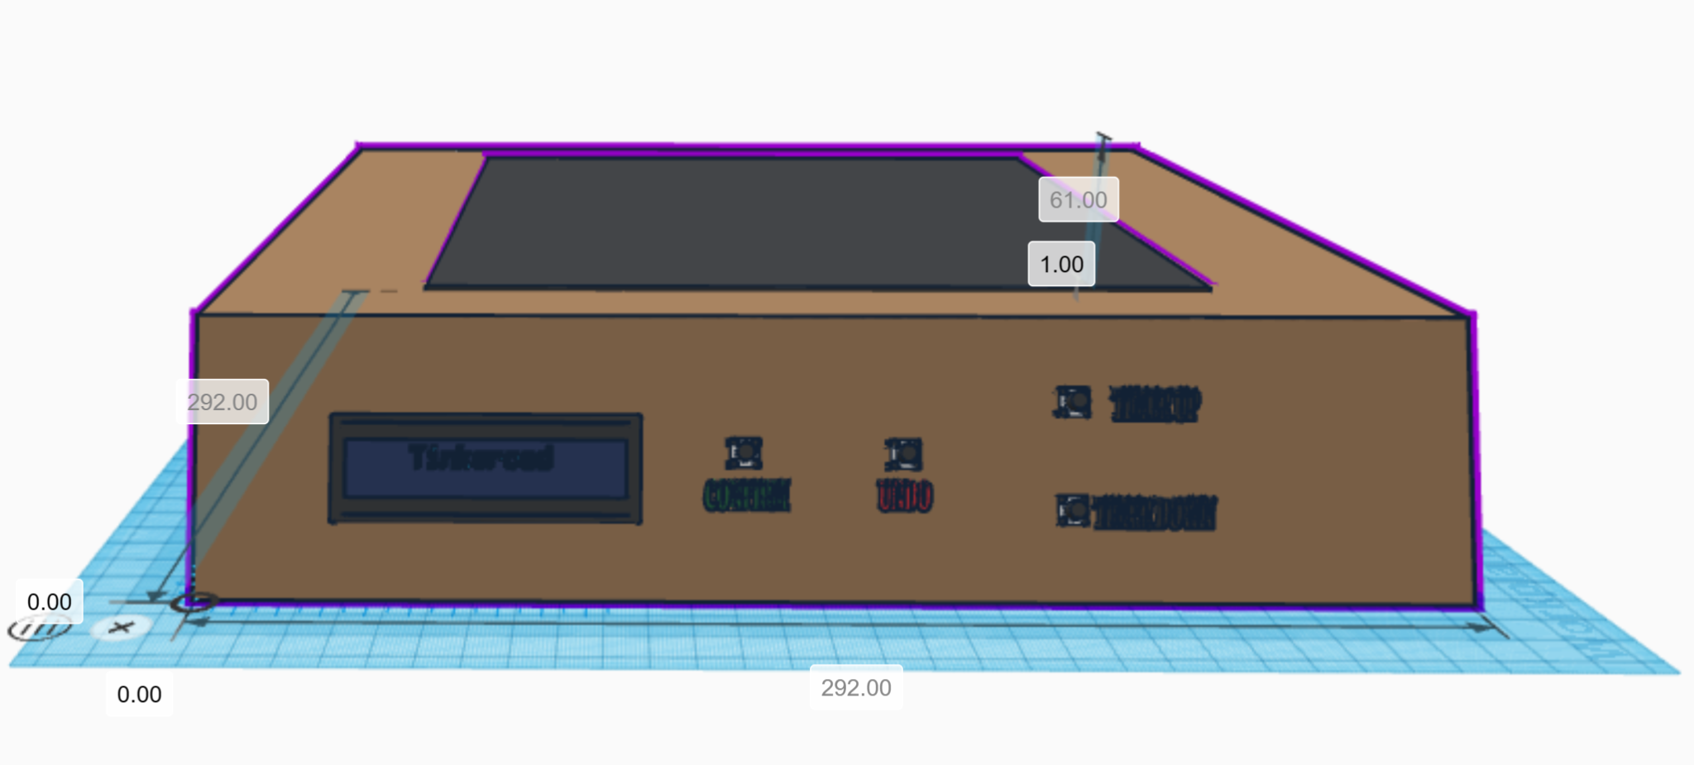

Figure 4: Player view of chess board

Appendix 2: Project Packaging Specifications

| Material | Quantity | Weight | Cost |
| --- | --- | --- | --- |
| Balsa Wood  or Plywood | 1900 cm2 | 453.6 g | $23 for stack of wood |
| Wood glue | 2 | 150.252 g | $4.52 |
| Wood Primer | 1 | 272.155 g | $7.47 |
| TOTAL: |  | 876.007 g | $34.99 |

Tooling Requirements:

We will need to use a woodshop to cut the wood for our product. Which we will be able to do at multiple places at Purdue, including but not limited to the Bechtel Design and Innovation Center.

Appendix 3: PCB Footprint Layout

The component footprint for the ADC will be an IC through hole connector. The Level Shifters and the MCP601 Op-Amp will use a TSSOP footprint. The STM32 will have a LQFP footprint. All of the headers will have through hole pins. The headphone and barrel jacks are both surface mount devices.

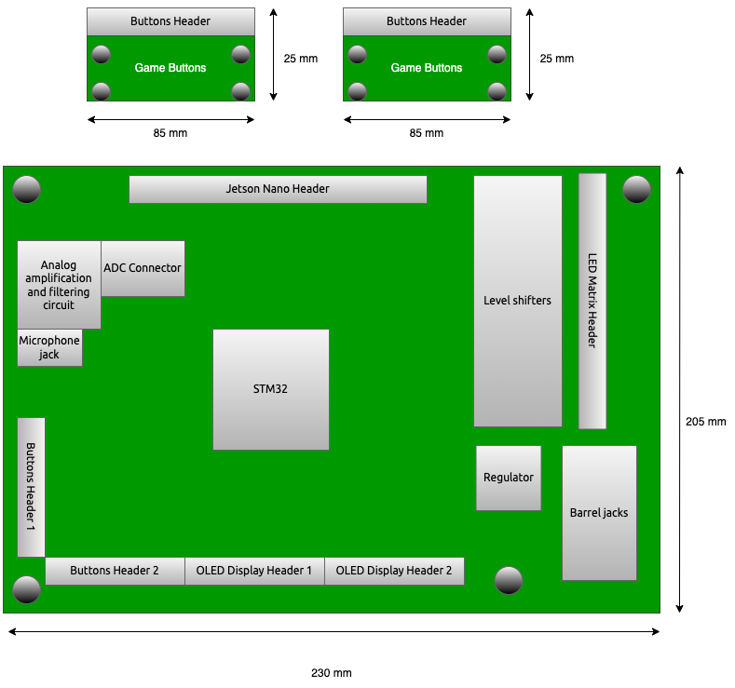

Figure 5: Prototype PCBs with general locations of devices.